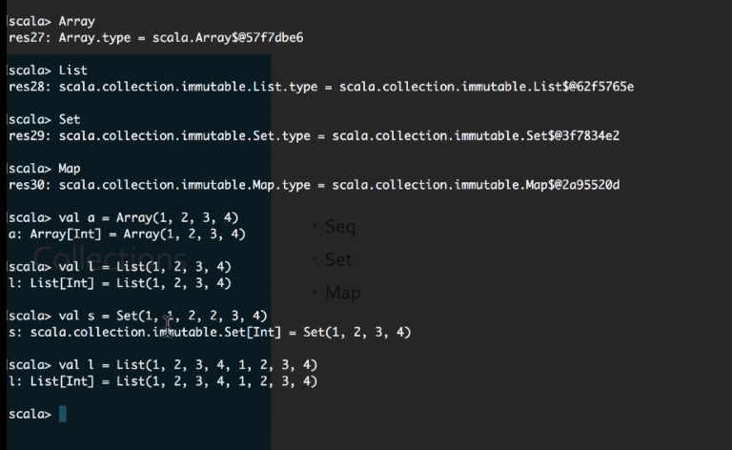

List allows duplicates , Set doesn’t allow duplicates

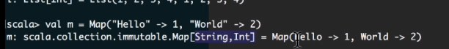

Map - key value pairs

Foreach is for iterating elements

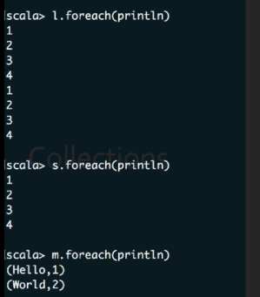

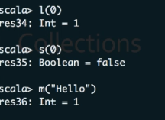

List to convert to Set

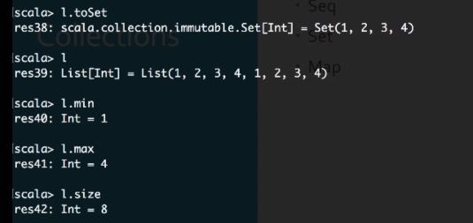

Map reduce operations

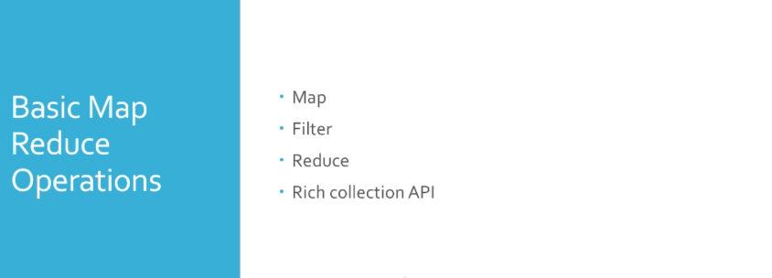

//Get sum of squares of all even numbers for 1..100 numbers

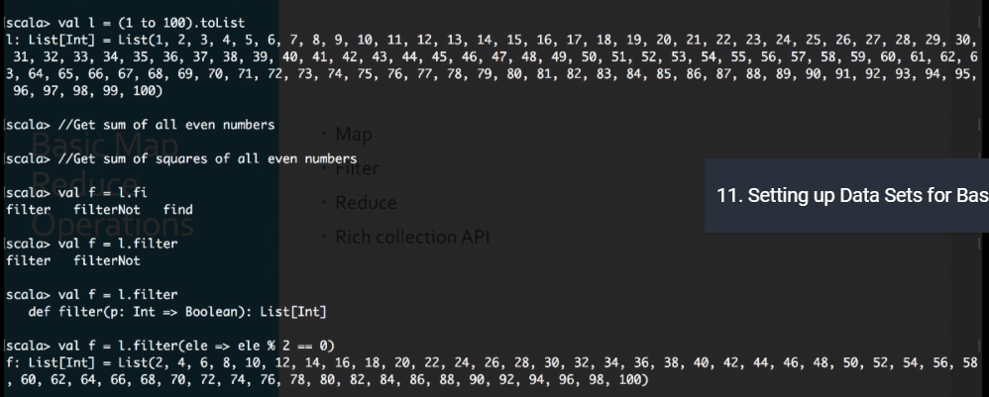

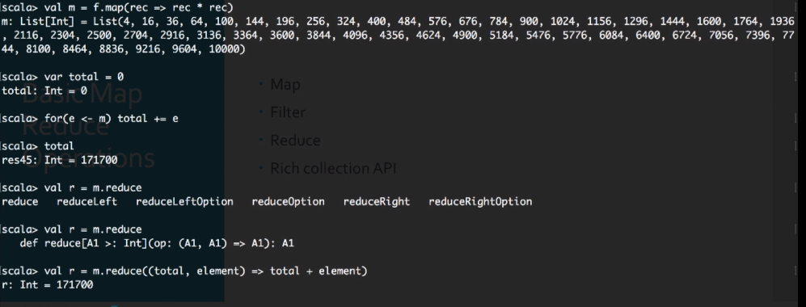

Last one can be:

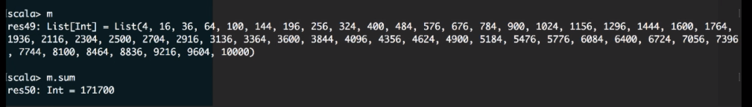

To set and sort

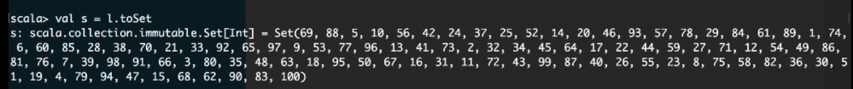

For set sort function is not there

For List we have sor function

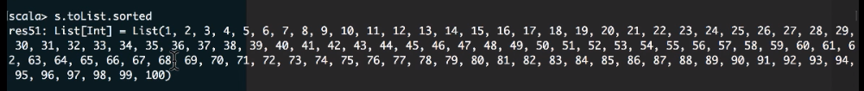

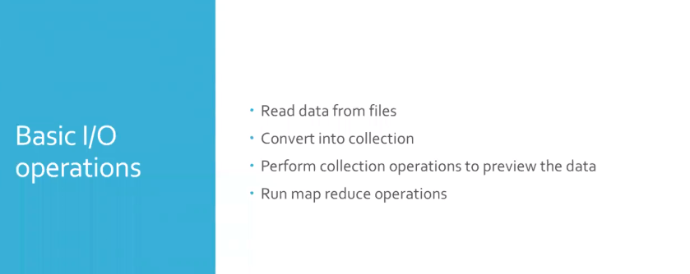

* Scala import scala.io.

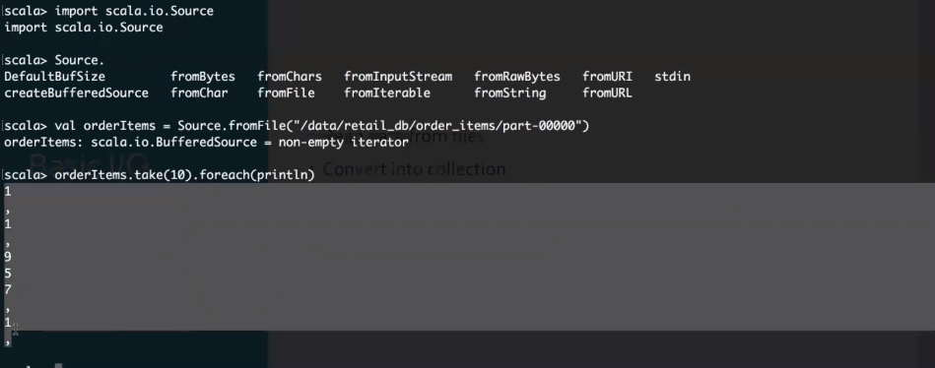

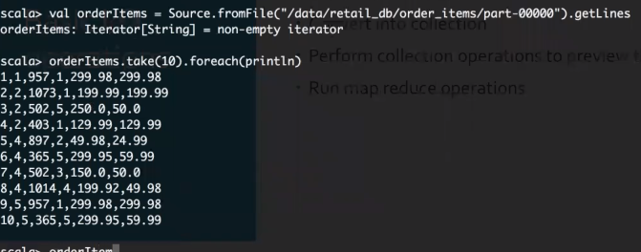

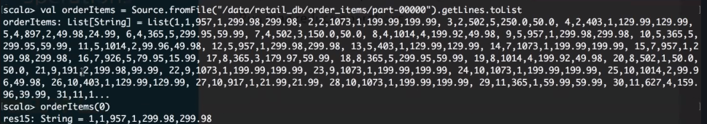

Where, 2nd item of each entry is 2.

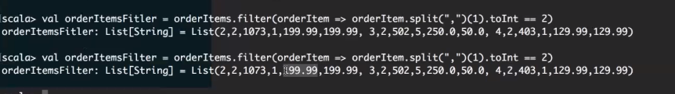



Like wise:



Otherways:

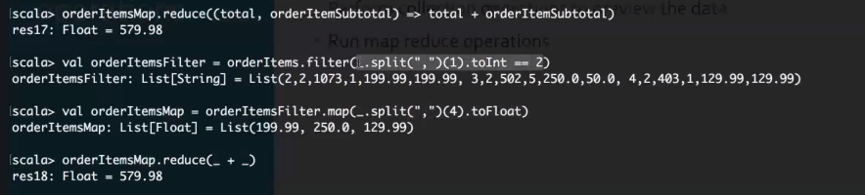

TUPLES

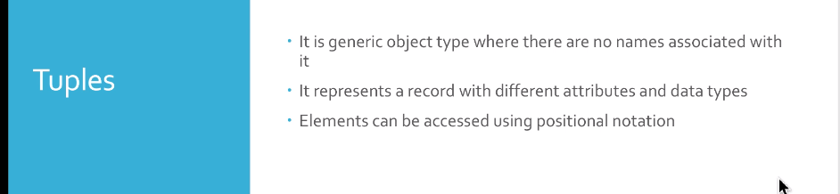

TUPLES index starts from 1 not from 0.

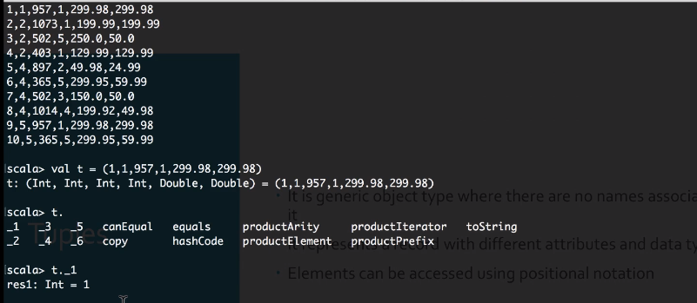

Tuples can be serializable







Create a file in directory:

Run the program.

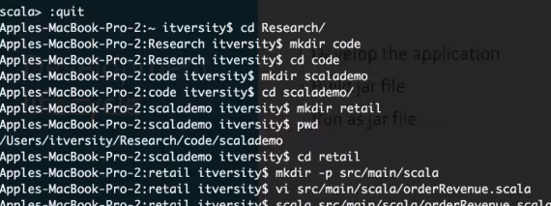

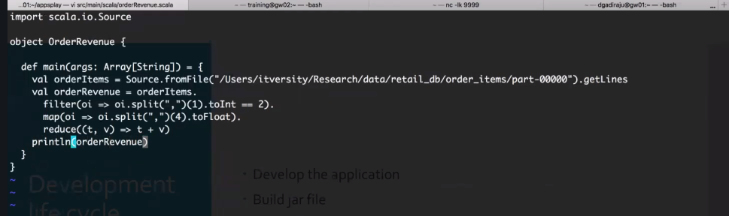

After file , run the file

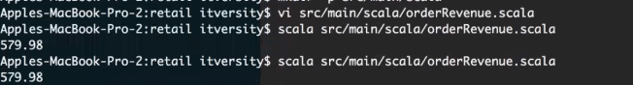

SBT ( Simple Build Tool ) .